The Business Accelerator
Figuring out what you want

Helping ambitious owners become great leaders by delivering

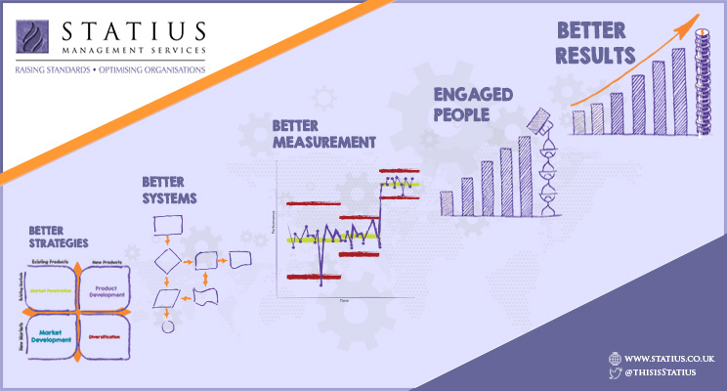

No man can reveal to you ought but that which already lies half asleep.
Kahlill Gibran, The Prophet

How to get the best from this exercise
I read a useful piece of advice sometime ago “to get the most from any situation, be there - wherever you are, be there!” As with anything in life the more you put in the more you're likely to get out.

If you want to get the best from these exercises then be here. Put everything else to one side and just be here as you work through the workbook.

All learning and change depends on the state you are in. Your results come from the way you behave, and the way you behave depends mostly on your state of mind, so here are some hints for getting into a useful state of mind to make the most of this exercise:

- Be here completely – make time for yourself.
- Write without evaluation or judging your thoughts.
- Take at least three deep breaths before each exercise, letting the air out slowly. This opens up your mind to consider creative possibilities.

You may choose to do all of the exercises together, alternatively, you can dip in and out of the exercises as you please. There is no need to complete every box if nothing springs to mind, its not an exam, the point is the exercises are designed to drive your thinking.
You alone get to decide if you wish to share any of your scribblings and thoughts, the answers will not be seen … but they will be useful to you for the next piece of work which will be done with your consultant and will involve mapping out those personal objectives you wish to share and your business objectives.
One thought that you might like to hold in your mind as you are doing this work, but you don’t have to, is, “What positive contributions do I want to make in my lifetime?”
You may also consider separating your answers between what you want at work and what you want outside of work, but again, it's up to you.

And finally, feel free to daydream freely. Imagine your ideal day in vivid detail and understand what life you are drawn to.

… this is a chance to just play with your thoughts…

Note: This template has deliberately been provided as a Word document so that, should you choose to type your answers, the boxes can expand and contract to contain the level of detail appropriate for your way of thinking.

Figuring out what you want #1
What do I want?
What do I really want?
If I could have anything, anything at all, what would I want?
What would be better than that?

Figuring out what you want #2 – Start small
One of the easiest ways to begin achieving what you want is to start small. What you want to happen, today, tomorrow, next week? What do you want from your next meeting, next sales call? What do you want from this afternoon?
Even if you really have no idea what you want in life, you probably have some idea of what you want from this evening or from your next meal.
Always have an outcome or a goal, whatever you are doing.
If you think about what you want and check your progress towards it, then you massively increase your chances of getting it.
So, it’s okay to have small goals especially ones that you are going to achieve easily. Success breeds success.
Start small with 5 things you want to achieve before you go to sleep tonight. Your list might look like this:
- To mow the grass
- To eat well and enjoy my food
- To talk to my partner about X
- To take the dog for a walk
- To phone a friend I have not spoken to for some time

When you are happy with the list, do it again, this time for the end of the week, then the end of the month.
Make a list of 5 things you want to achieve before you go to sleep tonight
Make a list of 5 things you want to achieve before the end of the week
Make a list of 5 things you want to achieve before the end of the month
Make a list of 5 things you want to achieve before the end of the year
Make a list of 5 things you want to achieve in 5 years
Make a list of 5 things you want to achieve in 10 years
Make a list of 5 things you want to achieve in 20 years
Make a list of 5 things you want to achieve in 30 years
Make a list of 5 things you want to achieve before you pass

Figuring out what you want #3 What do you wish for?
What do you really wish for and won’t it be great when you get it?
This exercise seeks to connect your wishes to real, practical actions that you can take. Stuff you need to do if you are to transform your wishes from fantasy to reality, all you have to do is link your wishes to goals and your goals to actions and find enough practical actions and your wishes will come true.
Step 1: “I wish” …Pick one or more things you wish for or want to achieve and that you want to explore in more detail
Step 2: Ask yourself “How could I make this come true?” Think of as many ways as possible. You will usually find that there are many more options than you first thought.
Step 3: Ask yourself “What would I need to do?” List all of the steps that you can think of.
Step 1 - I wish …. I want to achieve….. | Step 2 - How could I make this come true? | Step 3 - What would I need to do?

The above may be the beginning of your action plan…perhaps for the rest of your life!

Figuring out what you want #4 Follow your joy?
As children we can take a very selfish approach to life, we can pretty much do what we want most of the time, at least when we not at school, so, as a child we have carte blanche to follow our joy. As we get older commitments and responsibilities often “crowd out” our joy so we can lose sight of things we love doing.
The following exercise seeks to recapture those early (and perhaps later) experiences so that we can re-engage with our joy, so for each of the following age categories the questions to ask yourself are:
- What was the activity?
- What did you actually do?
- What specifically was the sense of joy?
- What abilities did you demonstrate by this accomplishment?
- What was the general subject matter?
- What were the circumstances?
- What were the relationships to other people and things?
At the age of 0-10 I really loved…
At the age of 11-15 I really loved…
At the age of 16-20 I really loved…
At the age of 11-

At the age of 21-30 I really loved…
At the age of 31-40 I really loved…
At the age of 41-50 I really loved…
At the age of 50+ I really loved…

Figuring out what you want #5 How am I doing?
Another way of figuring out what you want is to give yourself a score for how you are doing right now.
The circle below suggests a number of headings for the different areas of your life, use these headings or substitute some of your own, and give yourself a score out of 8 for how well you are currently doing.
8/8 represents everything is the way you want it to be and 0/8 is nothing the way you want it to be.
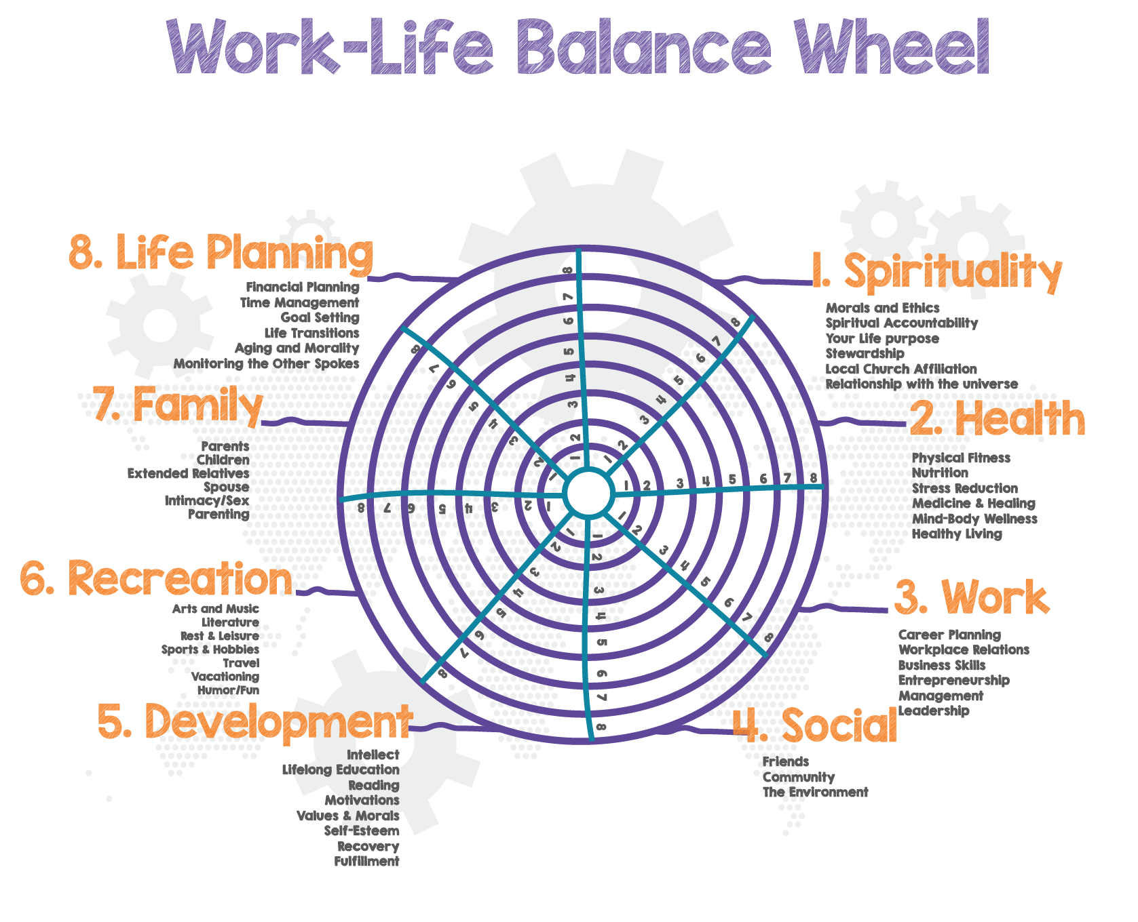
Now you may have noticed that this is a wheel and if you track around the wheel drawing your scores in from section to section and you find you have wildly different scores then you are probably experiencing a bit of a bumpy ride!
If you do have different scores, it might be worth revisiting the earlier exercises to work out what you need to do first to make the ride a little smoother.

Figuring out what you want #6 Pulling it all together
Now you have been through the exercises which might be complete with intimate detail or, for the big picture thinkers, might be just a few scribbled notes here, it’s now time to bring it all together.
The next exercise will put more flesh on the bones but it might be useful to collate your thoughts and jot down a few notes about what your personal and business objectives might be.
Personal objectives | Why is this important? | By when?

Business objectives | Why is this important? | By when?

BUT ISN’T ALL THIS JUST VERY SELFISH?

We don't think so. In fact, we'd very much argue that is the most selfless thing that you can do. After all, if you don't look after yourself properly how on earth will you be able to look after anyone else?

Additionally:

- The chances of you being here also infinitesimally small (it's been calculated at about 400 trillion to one, that’s 400 followed by 36 zero’s) are, we believe, such that ….
- And you are unique. There will only ever be one of you and you have a unique place here on the earth. You have only one life and one way to make it count is to begin to listen closely, see clearly and feel deeply for who you are and what you should be doing.
- The most generous thing you can do for the world is to find your own niche and do what you do best to the best of your ability.
- Too many people stay stuck in unhelpful circumstances or situations and wander through life with a vague sense of unease but never do anything about it.
- You tend to get what you focus on. Focus on how miserable things are and that’s how they will be. Tell yourself you don’t know what you want and you won’t.
- Now that you have a better idea of what you want, you have more choice, which gives you more control over what happens in your life.

- So, go figure it out and then go after it. It's huge fun…

These exercises will help you to be clear about what you want and to start getting the drive to do it.

Interestingly there was a guy called Ted Leonsis (I hadn't heard of him either) he was an early executive at AOL and made a fortune, he published his list of 101 things he wanted to do in seven categories, apparently, it's become a bit of a thing in some corners of the Internet. I don't think I'd be so open, and neither do you have to be but… one question:
- Qn: What's the difference between a dream and a plan?
- Ans: A plan is written down
Just writing things down makes the plan more concrete, even if you are the only audience.

Finally, just a bit of fun… A checklist for happiness
This is not really part of the exercise, and I can’t remember where I came across this first this idea but I suspect it was something to do with a cool guy called Julian Russell, descended from Bertrand Russell and a two time Prime Minister, Lord John Russell. So, he came from stock with pretty high expectations …its just a bit of fun to revisit once in a while.

A checklist for happiness? | Absolutely | Most of the time | Sometimes | Rarely | Never
My Life feels like a great adventure
I feel sure I can solve any problem I encounter
I have fun
I laugh out loud
I feel overwhelmed by gratitude
I spend time in comfortable solitude
I am fascinated by things I’m learning
I feel deeply understood
Thing seem to work out for me
I get so involved in projects I forget to stop
I use my imagination
I do things I loved when I was a kid
People seem to enjoy being around me
I play
I feel perfectly safe
I get excited when it’s time to go to work
I feel mentally sharp & alert
I have really cool ideas
I love my body
I’m flooded by love for other people
I do new things, or old things in new ways
I do what I want, even if it is scary
I am completely relaxed with other people
I feel intense physical pleasure
I am very pleased with how things are going

